CYBER SECURITY AND ARTIFICIAL INTELLIGENCE FOR CLOUD- BASED INTERNET OF TRANSPORTATION SYSTEMS
K. Vamsi
UG Student
Dept. of CSE(AIML&CS)
Godavari Institute of Engineering & Technology Rajahmundry, A.P
vamsikoribilli6281@gmail.com

N. Nani
UG Student
Dept. of CSE(AIML&CS)
Godavari Institute of Engineering & Technology Rajahmundry, A.P
neelapunani2580@gmail.com

S. Ratalu
Asst Professor,
Dept. of CSE(AIML&CS)
Godavari Global University Rajahmundry, A.P
ratalu@giet.ac.in

R. Tamilkodi
Professor,
Dept. of CSE(AIML&CS)
Godavari Global University Rajahmundry, A.P
tamil@giet.ac.in

P. Lohith Kumar
UG Student
Dept. of CSE(AIML&CS)
Godavari Institute of Engineering & Technology Rajahmundry, A.P
lohithkumar0003@gmail.com

V. Sowmya
UG Student
Dept. of CSE(AIML&CS)
Godavari Institute of Engineering & Technology Rajahmundry, A.P
swmya2384@gmail.com

Abstract: The Internet of Things (IoT) has major implications in the transportation industry. Autonomous Vehicles (AVs) aim at improving day-to-day activities such as delivering packages, improving traffic, and the transportations of goods. AVs are not limited to ground vehicles but also include aerial and sea vehicles with a wide range of applications. The IoT systems consisting of a collection of AVs have come to be known as the Internet of Transportation systems. While such IoT systems manage large quantities of sensor data, much of the data
is also sent to a cloud for offline analysis. While there is great potential in AVs and the improvements it can make to the transportation industry, security and privacy concerns pose new challenges that need to be addressed as we move forward. In addition, Artificial Intelligence techniques are also becoming crucial for such IoT systems to be able to intelligently manage the AVs. This paper discusses AI and security for cloud-based Internet of Transportation Systems.

1. INTRODUCTION
In the rapidly advancing landscape of technology, the integration of artificial intelligence (AI) and cyber security has become imperative, especially within the cloud-based Internet of Transportation Systems (IoTs). As transportation systems become more interconnected and reliant on cloud infrastructure, the need to fortify these networks against cyber threats become paramount. The introduction explores the intersection of AI and cybersecurity in the context of cloud-based IoTs, highlighting the significance of safeguarding transportation systems in an era of digital transformation.

2. LITERATURE SURVEY
Integrating AI With Cyber Security for Smart Industry 4.0 Application:
Authors: S.B. Goyal; Anand Singh Rajawat; Ram Kumar Solanki; Mohd Ariff Majmi Zaaba; Zalizah Awang Long
The advent of Smart Industry 4.0 has brought about significant advances in automation, efficiency, and productivity in industrial environments. However, these technological advances also pose new challenges for cybersecurity. The increasing interconnectivity of devices and systems within Smart Industry 4.0 environments makes them vulnerable to cyber attacks and security breaches. To address these challenges, there is a need to integrate AI with cybersecurity in Smart Industry 4.0 applications. AI can be used to analyse large amounts of data from sensors and devices within the industrial environment to detect and prevent cyber threats. Machine learning algorithms can be trained to identify patterns of normal behaviour and flag any deviations as potential security threats.
Trustworthy Machine Learning for Securing IoT Systems:
Authors: Bhavani Thuraisingham
This paper first describes the security and privacy challenges for the Internet of Things IoT) systems and then discusses some of the solutions that have been proposed. It also describes aspects of Trustworthy Machine Learning (TML) and then discusses how TML may be applied to handle some of the security and privacy challenges for IoT systems.
Enhancing Security and Scalability of Metaverse with Blockchain-based Consensus Mechanisms:
Authors: Anand Singh Rajawat; S.B. Goyal; Aarti Goyal; Kavita Rajawat; Maria Simona Raboaca
This study examines how blockchain technology and consensus mechanisms can safeguard and grow the metaverse ecosystem. Blockchain is transparent and decentralized. It is unchangeable, cryptographically verified, and runs without a central authority. Blockchain technology can secure the metaverse and users' data. This study compares blockchain-based consensus algorithms such as POW(PoW), PoS, and PBFT to ensure metaverse safety. These consensus mechanisms provide safe, decentralized transaction verification, waste reduction, and network consensus. Studying blockchain technology's metaverse scaling restrictions and scaling solutions, including sharding, sidechains, and off-chain protocols. These methods increase throughput, parallel computing, and transaction speed. They improve the metaverse's eco-system. Quantitative analysis, simulations, and experiments determine the security and scalability of blockchain-based metaverse consensus processes. Changes will be quantified by measuring transaction speed, network throughput, and resource consumption. This study enables safe, scalable metaverse environments. Blockchain-based consensus mechanisms allow the metaverse to retain user data safely, halt undesirable conduct, and allow users to join without trusting each other. Scalability solutions declutter networks, enabling the metaverse to handle more individuals and transactions. Blockchain-based consensus mechanisms could make the metaverse more secure, private, and scalable. Users will trust each other, create new apps, and be more open to this groundbreaking digital world.
Towards a Privacy-Aware Quantified Self Data Management Framework:
Authors: Bhavani Thuriasingham, Murat kantarcioglu, Elisa bertino
Massive amounts of data are being collected, stored, and analysed for various business and marketing purposes. While such data analysis is critical for many applications, it could also violate the privacy of individuals. This paper describes the issues involved in designing a privacy aware data management framework for collecting, storing, and analysing the data. We also discuss behavioural aspects of data sharing as well as aspects of a formal framework based on rewriting rules that encompasses the privacy aware data management framework.
Application of User and Entity Behavioural Analytics (UEBA) in the Detection of Cyber Threats and Vulnerabilities Management:
Authors: Rahma Olaniyan, Sandip Rakshit
Technological advancements such as the Internet of Things, mobile technology, and cloud computing are embraced by organizations, individuals, and society. The world is becoming more reliant on open networks, which fosters global communication and cloud technologies like Amazon Web Services to store sensitive data and personal information. This changes the danger landscape and opens new opportunities. As the number of people who use the Internet grows, so does the number of cyber risks and data security challenges that hackers pose. A cybersecurity threat is an action that aims to destroy or damage data, steal data, or otherwise disrupt digital life. Computer viruses, data breaches, and Denial of Service (DoS) assaults are all examples of cyber dangers. We'd be witnessing a notion of scanning enormous volumes of data across the internet if we described how AI systems might discover where hacks came from and recommend solutions to decision-makers within the corporation. Keywords Artificial intelligence Machine learning UEBA Cybersecurity threats Vulnerability Machine learning Security
Summary of Drawbacks:
Integrating AI-based cybersecurity solutions for Industry 4.0 or IoT systems requires sophisticated design and configuration. Misconfigurations or improper implementations may lead to unintended vulnerabilities, reducing overall effectiveness.
While privacy-aware data management frameworks offer solutions to mitigate privacy violations, they struggle with balancing data sharing and privacy, especially in the context of massive data collection in IoT or quantified-self applications. Behavioural aspects of data sharing introduce further complexities in ensuring complete privacy compliance.
Trustworthy Machine Learning (TML) for securing IoT and other systems may struggle with ensuring model accuracy and trust in highly dynamic environments. False positives in detection systems can cause unnecessary alarms, while false negatives leave systems vulnerable to undetected threats.
Positioning of Our Work:
In the context of the rapidly evolving landscape of transportation systems that leverage cloud computing and the Internet of Things (IoT), our work positions itself at the intersection of cybersecurity and artificial intelligence. The integration of AI with cybersecurity frameworks is crucial for ensuring the safety, reliability, and resilience of cloud-based transportation systems. Here’s how our work is positioned:
As transportation systems become increasingly interconnected, they are vulnerable to cyber threats such as data breaches, denial-of-service attacks, and unauthorized access. Our research focuses on developing advanced AI-driven cybersecurity solutions that can proactively detect and mitigate these threats, thereby enhancing the overall security posture of cloud-based transportation systems.
Our work emphasizes the importance of real-time monitoring and response to cyber threats. By implementing AI techniques such as anomaly detection and predictive analytics, we aim to create systems that can swiftly identify and respond to potential cyber threats in cloud-based transportation environments.
3. METHODOLOGY
a) Proposed Work:

The proposed system aims to implementing Cyber Security (CS) based data transfer to Autonomous vehicle to overcome the existing problems. Here a cloud is the mediator that which transfers sender files to autonomous vehicle with more security we are using CP-ABE based algorithm which is used to hide the transferred data into cipher text. The cipher text can be decrypted by the private key generated by sender to the particular AV.

b) System Architecture:
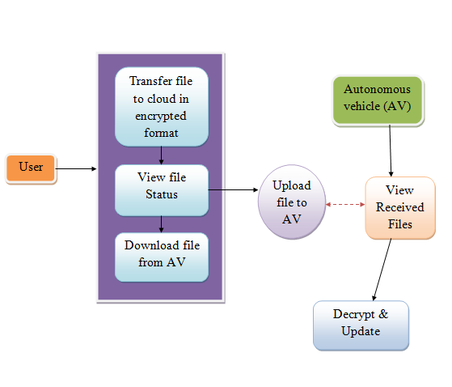
Fig1 Proposed Architecture
In the context of an autonomous vehicle (AV) system architecture, the process begins with transferring files to the cloud in an encrypted format to ensure data security during transmission and storage. Once files are uploaded, users can view the file status to check for successful transfers or errors. Files can also be downloaded from the AV to local systems for analysis or backup, while uploading allows for the transfer of necessary data, such as updates or maps, back to the AV. Additionally, users can view received files to verify their integrity and correctness. After retrieving files, decryption is performed to make the data readable, followed by updates to the vehicle's system, ensuring it operates efficiently with the latest information and configurations.
c) Data Processing:
Removing the URL and other characters: In this step, URLs within the textual data are removed to eliminate irrelevant information and standardize the content. This ensures that any external links, which may not contribute to the core analysis, are excluded from the text. Additionally, special characters, symbols, and non-alphanumeric characters are stripped from the text. This process cleanses the data by removing extraneous elements that can interfere with text processing and analysis. By focusing solely on relevant text, the consistency of the dataset is improved, facilitating more efficient and accurate feature extraction. This cleanup enhances the overall quality of the data, allowing for more effective subsequent analysis and processing. It helps ensure that the text is streamlined and uniformly formatted, which is crucial for developing robust and reliable fake news detection algorithms.
Remove Punctuations: Punctuation marks, including periods, commas, exclamation points, and question marks, are removed from the text to minimize noise and enhance text analysis tasks. Although punctuation is essential for structuring language and conveying meaning, its presence can interfere with processes like sentiment analysis or keyword extraction. By stripping out these punctuation marks, the text becomes cleaner and more uniform, which aids in achieving more accurate and reliable results in subsequent analysis. This preprocessing step helps streamline the data, making it better suited for tasks such as feature extraction and semantic interpretation. With punctuation removed, the focus shifts to the core content of the text, allowing for clearer insights into the underlying meaning and improving the overall effectiveness of fake news detection algorithms. This step is crucial for refining the quality of the data and ensuring more precise analysis outcomes.
Remove Stop Words: Stop words, such as "the," "is," and "and," are removed from the text to minimize noise and emphasize meaningful content. These commonly occurring words typically carry minimal semantic value and appear frequently across documents, offering little distinction between genuine and fake news. By eliminating stop words, the focus shifts to more relevant and informative terms that contribute to the core message of the text. This preprocessing step streamlines the text analysis process, enhancing the efficiency of feature extraction and classification algorithms. It helps to prioritize significant terms and phrases that are crucial for distinguishing between different types of content. As a result, the text becomes cleaner and more focused, improving the accuracy and effectiveness of subsequent analysis and model performance in fake news detection. This approach ensures that the analysis concentrates on the content that truly impacts the classification outcomes.
d) Feature Selection:
Feature selection is a critical component in the data processing pipeline for fake news detection. It involves identifying and retaining the most relevant features from the pre-processed data while removing those that are irrelevant or redundant. In the context of textual data, common feature selection techniques include term frequency-inverse document frequency (TF-IDF), which prioritizes words that are highly indicative of the content's uniqueness and discriminative power. This method helps in emphasizing terms that are significant for distinguishing between genuine and fake news articles.
Additionally, methods such as chi-square tests or mutual information gain can be employed to evaluate the importance of individual features. Chi-square assesses the association between features and the target variable, while mutual information measures the dependency between features and the outcome. By applying these techniques, the system can identify the most informative features and improve classification accuracy. Effective feature selection reduces the risk of overfitting, where the model may otherwise become too complex and perform poorly on unseen data. Overall, careful feature selection enhances the performance of fake news detection algorithms, ensuring more accurate and reliable results.
e) Training & Testing:
In the training phase, the pre-processed and feature-selected data are used to train machine learning models for fake news detection. This process involves inputting the labelled training dataset into the learning algorithm, which iteratively adjusts its parameters to minimize classification errors and enhance its ability to distinguish between genuine and fake news. During this phase, the model learns patterns and features that are indicative of fake news, optimizing its internal parameters based on the training data. This training process is crucial as it equips the model with the knowledge required to make accurate predictions when encountering new, unseen data.
After training, the model’s performance is evaluated using a testing dataset, which is a separate set of labelled data not utilized during the training phase. By testing on this separate dataset, the system provides an unbiased assessment of the model's ability to generalize its learning to new data. The testing phase is essential for determining how well the model can classify unseen instances of news as genuine or fake. By using distinct datasets for training and testing, the framework ensures that the model is robust and generalizes well to new, unseen examples, reducing the risk of overfitting. Typically, an 80-20 split is used, where 80% of the data is allocated for training and 20% for testing, striking a balance between effective learning and rigorous evaluation. This method helps in validating the system's effectiveness in real-world scenarios, ensuring that the fake news detection framework can reliably identify misinformation.
f) Algorithms:
CPABE Algorithm
The Ciphertext-Policy Attribute-Based Encryption (CPABE) algorithm is a cryptographic scheme that allows for fine-grained access control over encrypted data based on user attributes. In CPABE, each user is associated with a set of attributes, and the data owner defines an access policy specifying which attributes a user must possess to decrypt the data. The encryption process involves creating a ciphertext that is tied to the access policy, while users generate their secret keys based on their attributes. When a user attempts to decrypt the ciphertext, the algorithm checks if the user's attributes satisfy the policy embedded in the ciphertext. If they do, the user can successfully decrypt the data; if not, access is denied. This mechanism provides a secure and flexible way to manage data access in scenarios where multiple users with varying permissions interact with sensitive information.

4. EXPERIMENTAL RESULTS

Fig 4 Home Page

Fig 5 Registration Page

Fig 6 Login Page

Fig 7 Upload Files to cloud
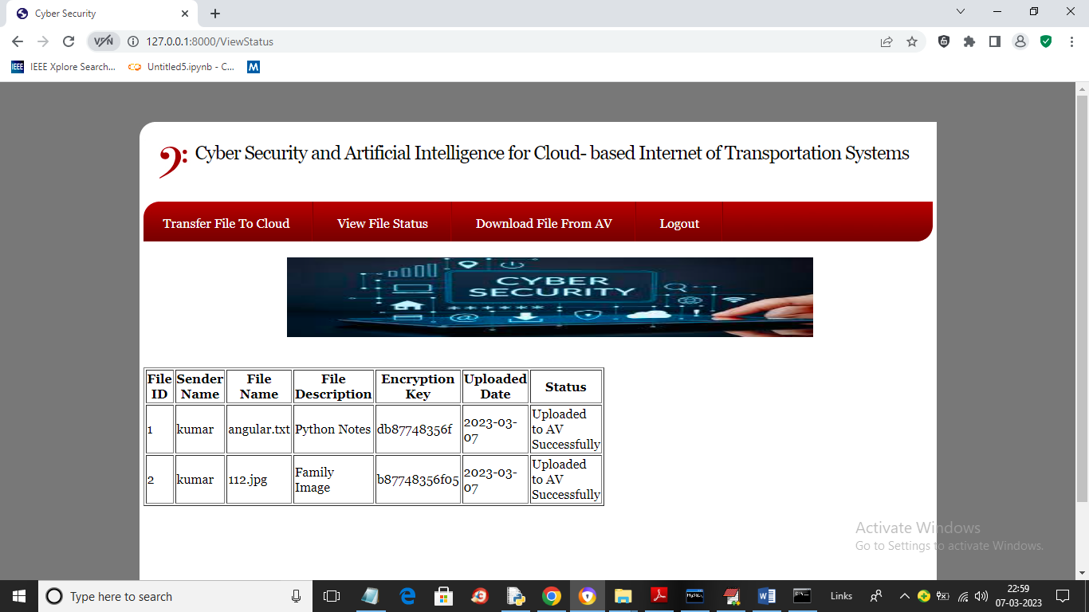
Fig 8 View status
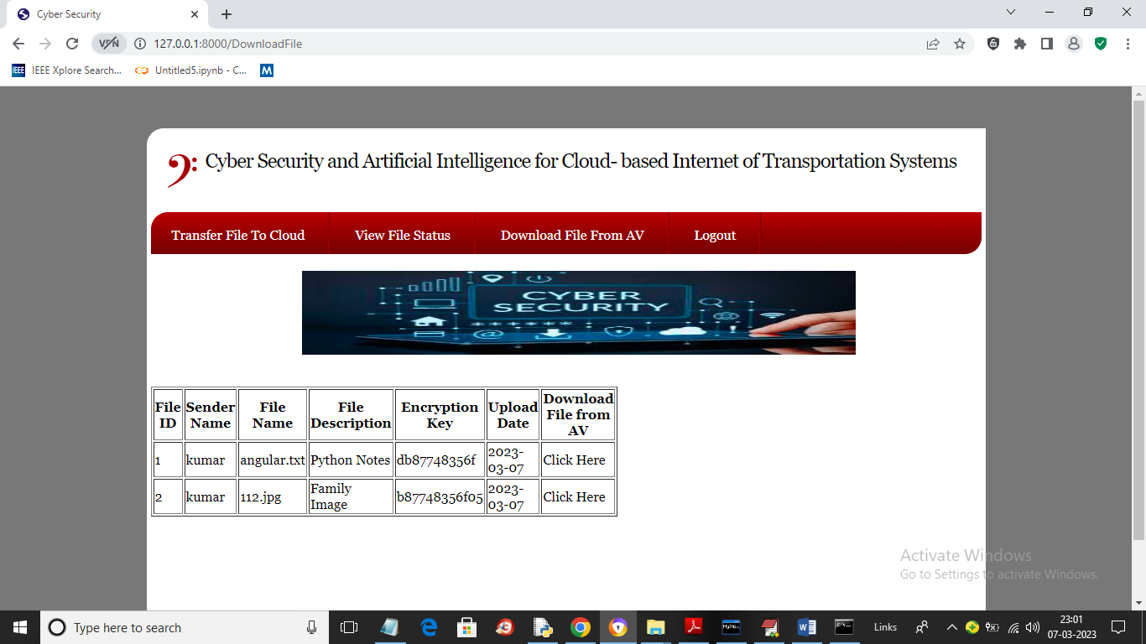
Fig 9 Download file from AV
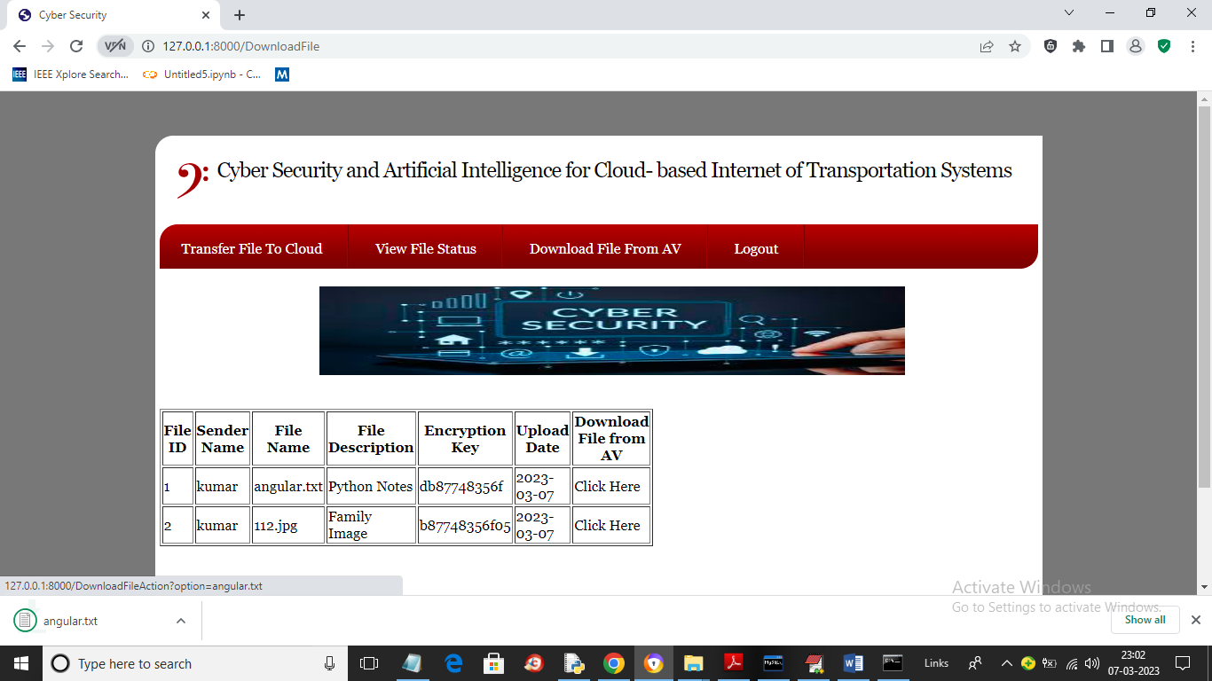
Fig 10 click here link to download

Fig 11 AV Login
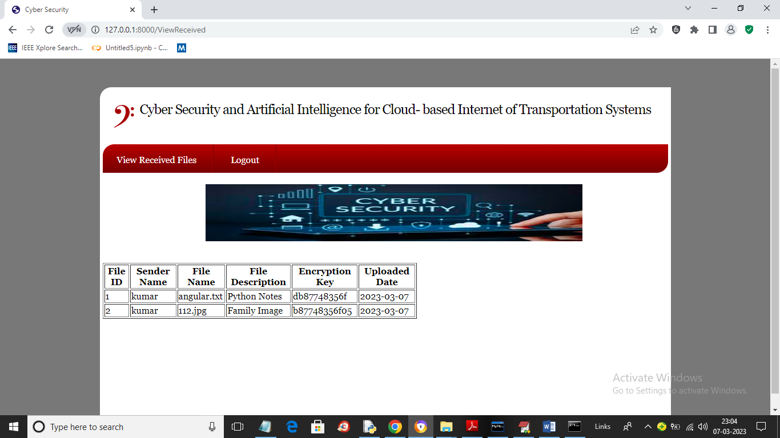
Fig 12 view received files

5. CONCLUSION
In conclusion, Intelligence for Cloud-based Internet of Transportation Systems" successfully bridges the realms of cutting-edge technology and security in modern transportation networks. By synergizing AI-driven anomaly detection and robust cyber security measures, the project contributes to safeguarding cloud-based transportation systems against emerging threats. Continuous monitoring, adaptation, and collaboration are vital components in this evolving landscape. Safeguarding transportation networks through comprehensive cybersecurity measures not only protects sensitive information but also contributes to the sustained efficiency and safety of advancement and interconnected systems.
6. FUTURE SCOPE
The future scope in the realm of cloud-based Internet of Transportation and artificial intelligence cybersecurity is promising.
Key areas for advancement include:
- Advanced Threat Detection: developing more AI algorithms for real-time detection, anomaly identification, and predictive analysis to proactively address emerging cyber threats.
- Quantum-safe Cryptography: exploring & implementing quantum –resistant cryptographic techniques to ensure security.
- Regulatory Frameworks

REFERENCES
[1] R. Quinonez, J. Giraldo, L. Salazar, E. Bauman, A. Cardenas, Z. Lin, Securing Autonomous Vehicles with a Robust Physics-Based Anomaly Detector. 29th USENIX Security Symposium (USENIX Security 20). Boston, MA, August 2020.
[2] M. Masood, L. Khan, and B. Thuraisingham, Data Mining Applications in Malware Detection, CRC Press 2011.
[3] Y. Zhou, M. Kantarcioglu, B. M. Thuraisingham, B. Xi, Adversarial support vector machine learning. ACM KDD 2012: 1059-1067
[4] B. M. Thuraisingham, SecAI: Integrating Cyber Security and Artificial Intelligence with Applications in Internet of Transportation and Infrastructures, Clemson University Center for Connected Multimodal Mobility, Annual Conference, October 2019.
[5] B. M. Thuraisingham, P Pallabi, M. Masud, L. Khan, Big Data Analytics with Applications in Insider Threat Detection, CRC Press, 2017.
[6] K. W. Hamlen, V. Mohan, M. M. Masud, L. Khan, B. M. Thuraisingham: Exploiting an antivirus interface. Comput. Stand. Interfaces 31(6): 1182- 1189 (2009)
[7] L. Liu, M. Kantarcioglu, B. M. Thuraisingham: The applicability of the perturbation based privacy preserving data mining for real-world data. Data Knowl. Eng. 65(1): 5-21 (2008)
[8] B. M. Thuraisingham, M. Kantarcioglu, E. Bertino, J. Z. Bakdash, M. Fernández, Towards a Privacy-Aware Quantified Self Data Management Framework. SACMAT, pp 173-184, 2018 [9] K. W. Hamlen, M. Kantarcioglu, L. Khan, B. M. Thuraisingham, Security Issues for Cloud Computing. IJISP 4(2): 36-48 (2010)
[10] Y. Li, Y. Gao, G. Ayoade, H. Tao, L. Khan, B. M. Thuraisingham, Multistream Classification for Cyber Threat Data with Heterogeneous Feature Space. WWW, pp 2992-2998, 2019
[11] H. Qiu, Q. Zheng, G. Memmi, J. Lu, M. Qiu, B. M. Thuraisingham, "Deep Residual Learning based Enhanced JPEG Compression in the Internet of Things", accepted by IEEE Transactions on Industrial Informatics, 2020
[12] G. Ayoade, V. Karande, L. Khan, K. W. Hamlen, Decentralized IoT Data Management Using BlockChain and Trusted Execution Environment. IRI, pp 15-22, 2018

